MODULE 1-4

1. Install VirtualBox or VMware. Set up a virtual machine with any Linux distribution (preferably Kali Linux).

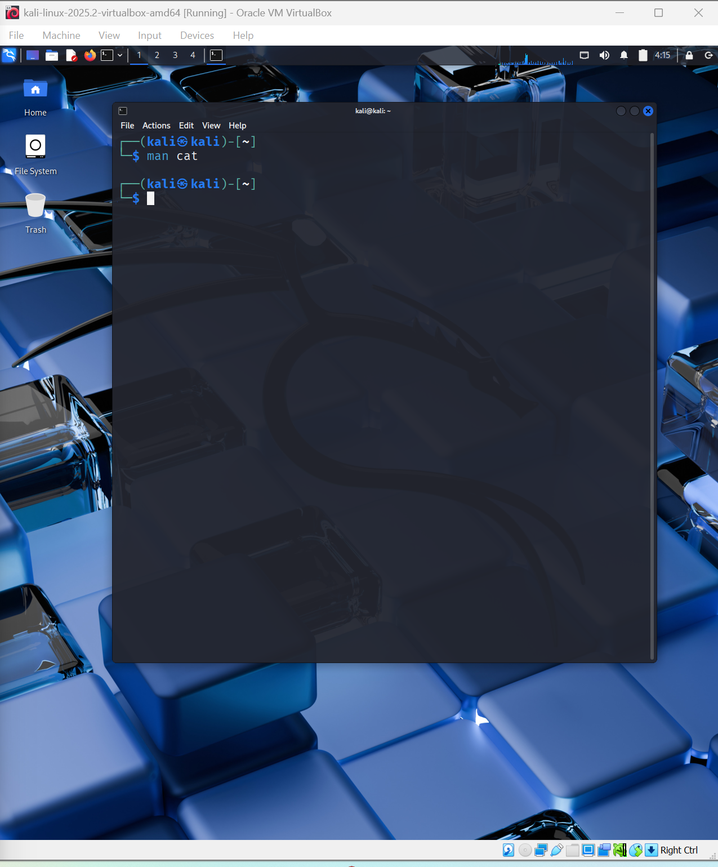

**2.**  Install Kali Linux in your virtual machine and update it..

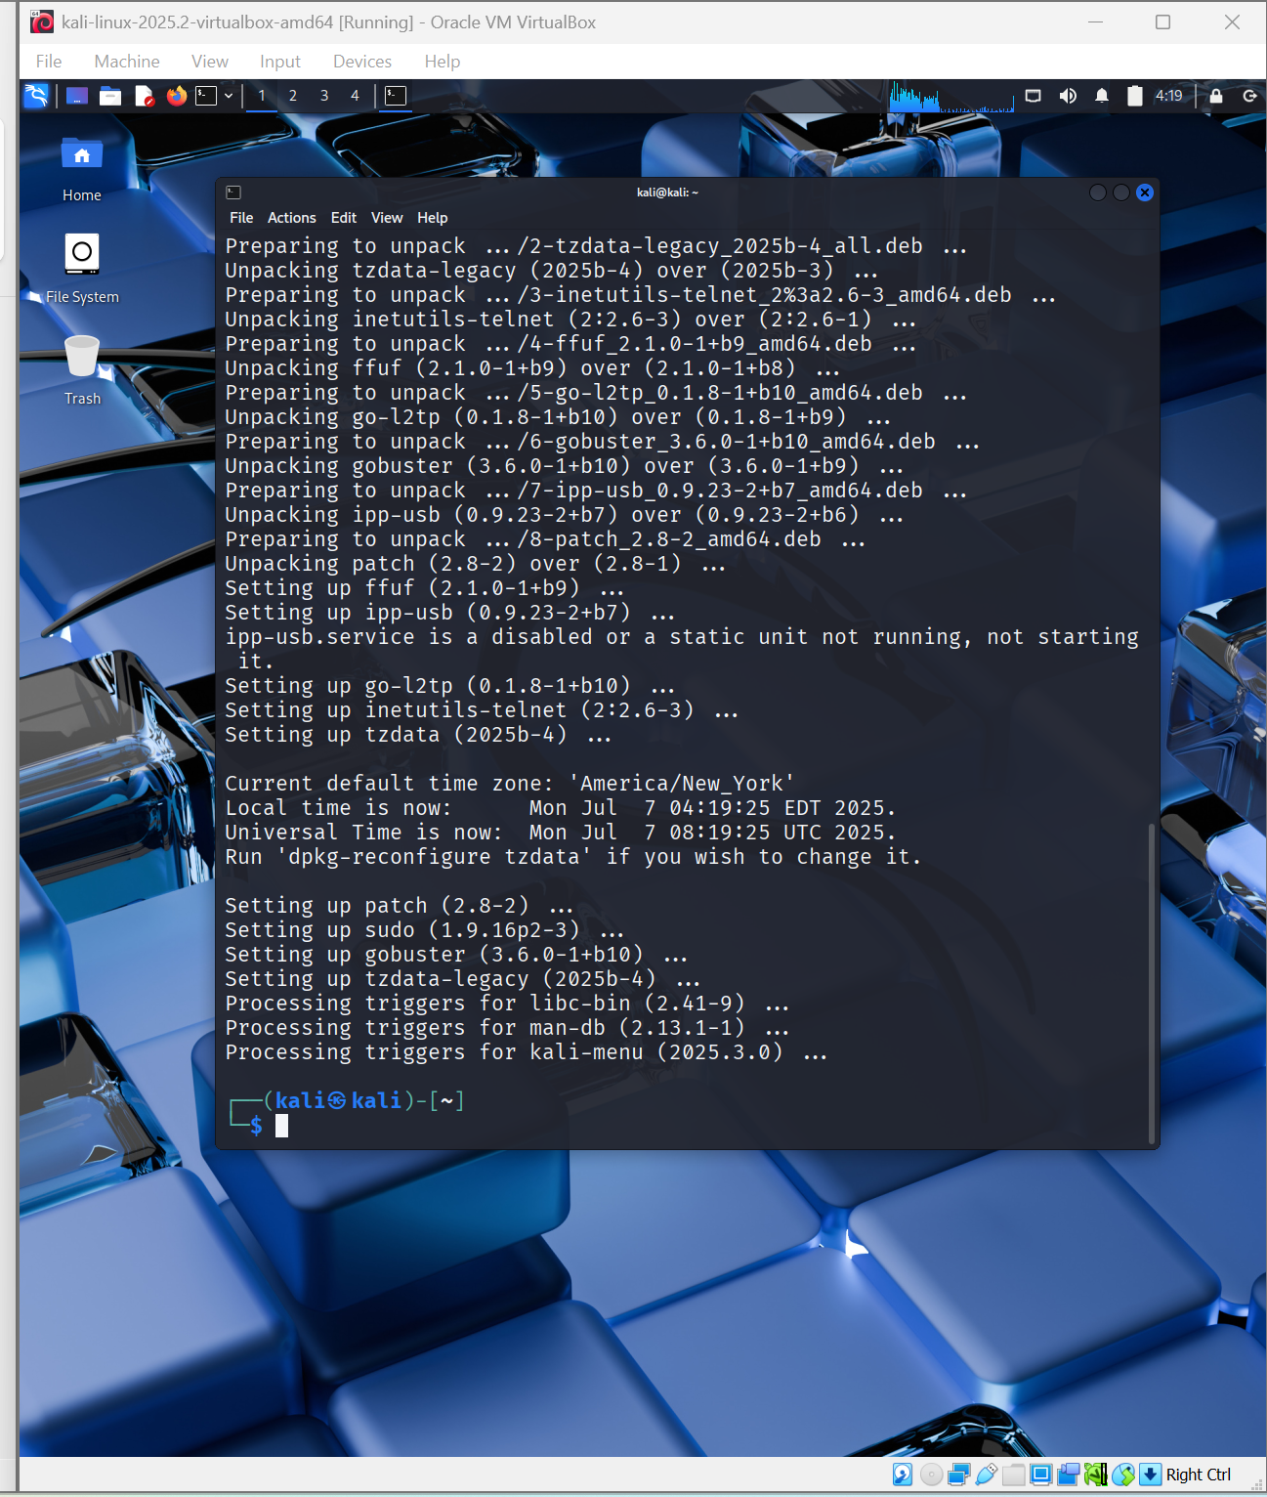

1. Explore the applications menu in Kali Linux. List 5 tools and their purpose.

Som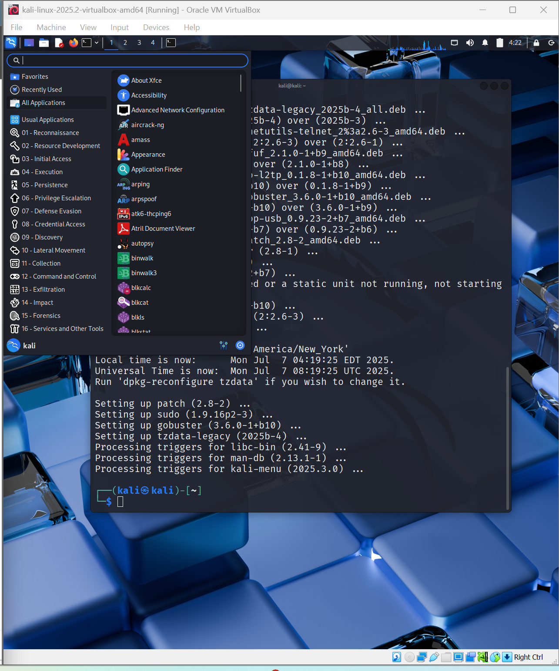

5 tools on kali:

1. arpspoof : a command line utility used to simulate Man-In-The-Middle attack on local networks
2. bully: a tool used to expoit the Wifi Protected Setup vulnerabilities using brute force attack.
3. crunch : a wordlist generator; we can specify the characters to be used, min and max lengths
4. dirbuster: tool for exposing hidden directories and files on web-servers
5. nmap: short form for Network Mapper, tool for network scanning

**4.** Execute the following Linux commands:

a. find command

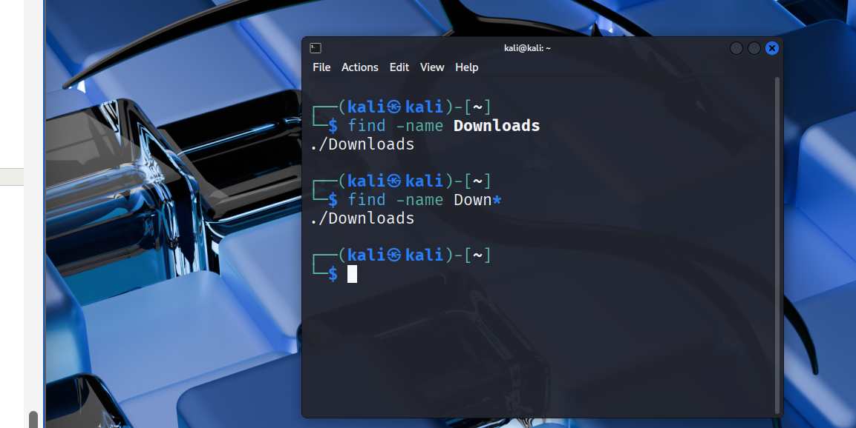

b. ping command

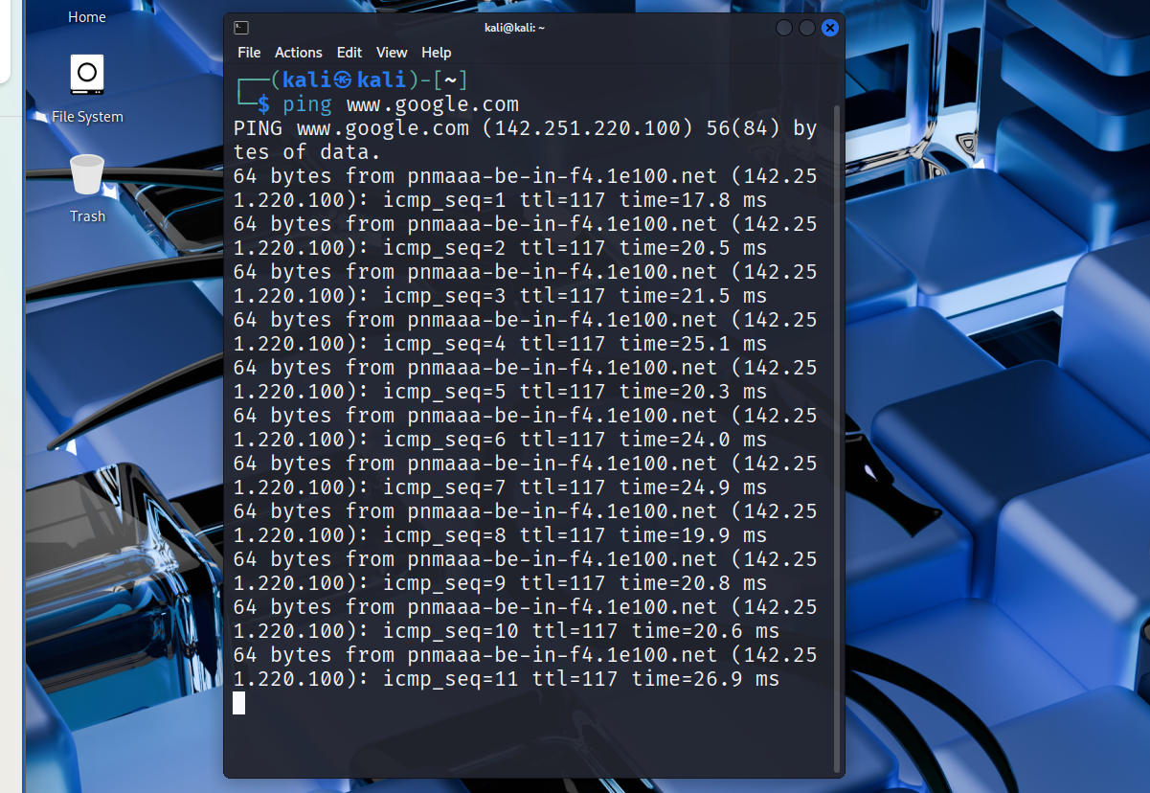

c. traceroute command

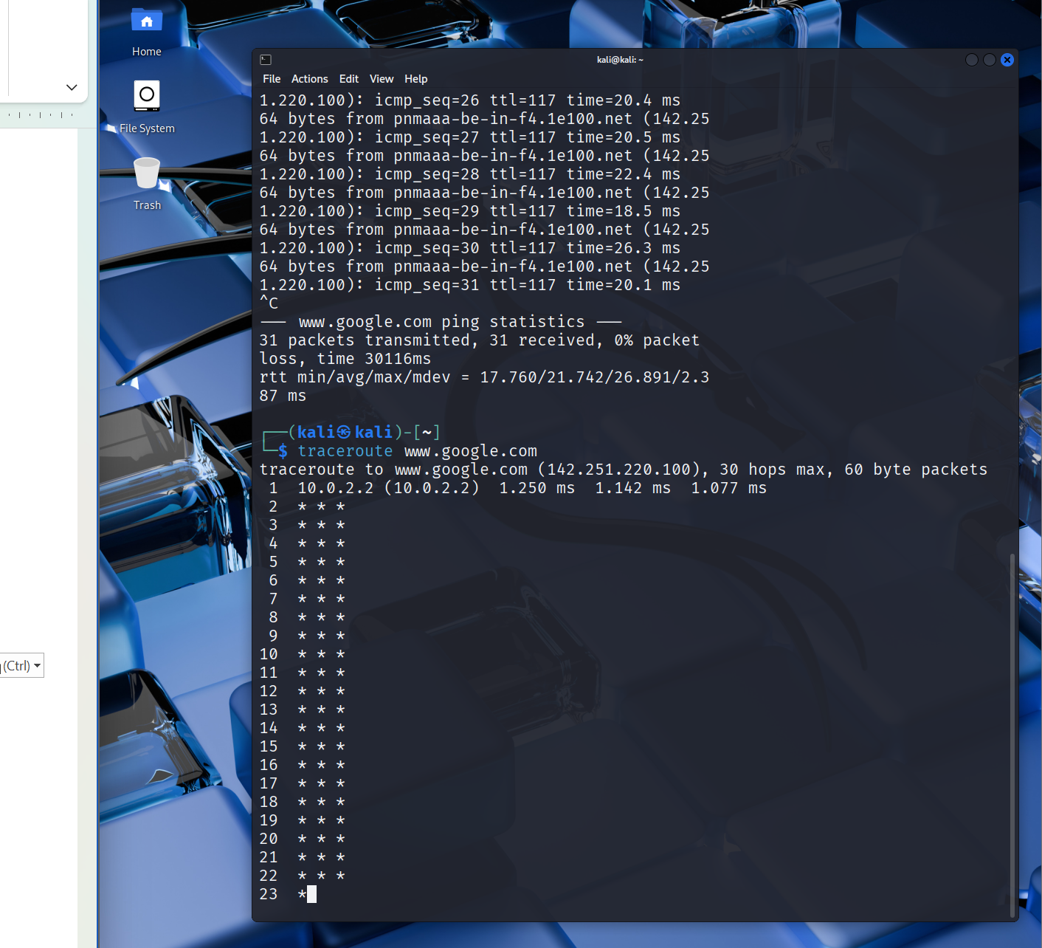

d. whoami command

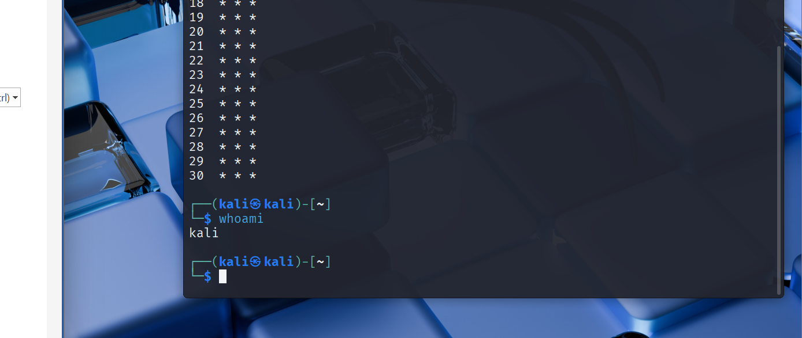

e. ps command

